**DAILY ONLINE ACTIVITIES SUMMARY**

|  |  |  |  |  |  |  |  |
| --- | --- | --- | --- | --- | --- | --- | --- |
| **Date:** | **18/07/2020** | | | | **Name:** | **Namratha C** | |
| **Sem & Sec** | **8th sem, A sec** | | | | **USN:** | **4AL16CS056** | |
| **Online Test Summary** | | | | | | | |
| **Subject** | | **NA** | | | | | |
| **Max. Marks** | |  | | **Score** | |  | |
| **Certification Course Summary** | | | | | | | |
| **Course** | **Introduction to Digital Marketing** | | | | | | |
| **Certificate Provider** | | | **Great Learning** | **Duration** | | | **2.5 hrs** |
| **Coding Challenges** | | | | | | | |
| **Problem Statement: Java Program to break integer into digits**  **{**  **// Method 1: Using String object**  **char[] ch = {'g', 'o', 'o', 'd', ' ', 'm', 'o', 'r', 'n', 'i', 'n', 'g'};**  **String str = new String(ch);**  **System.out.println(str);**    **// Method 2: Using valueOf method**  **String str2 = String.valueOf(ch);**  **System.out.println(str2);**  **}**  **}** | | | | | | | |
| **Status: Completed** | | | | | | | |
| **Uploaded the report in Github** | | | | **Yes** | | | |
| **If yes Repository name** | | | | **CODES(Namrathasonu)** | | | |
| **Uploaded the report in slack** | | | | **Yes** | | | |

Online Test Details: No test conducted

Certification Course Details:

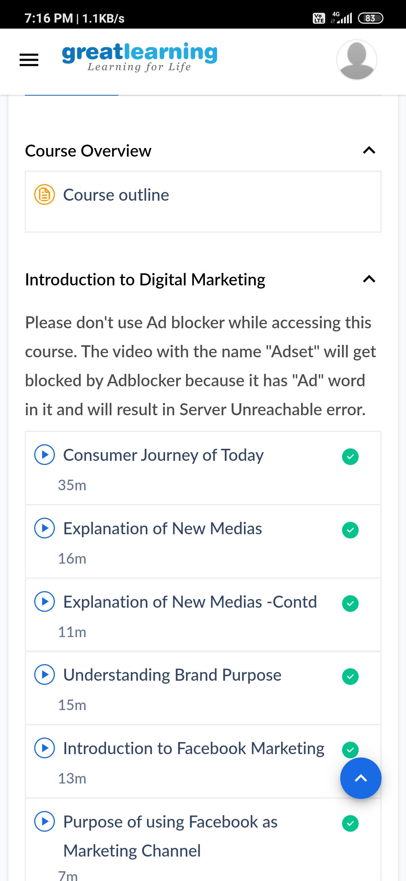

Coding Challenges Details:

import java.util.Scanner;

class JavaExample

{

public static void main(String[ ] arg)

{

boolean isVowel=false;;

Scanner scanner=new Scanner(System.in);

System.out.println("Enter a character : ");

char ch=scanner.next().charAt(0);

scanner.close();

switch(ch)

{

case 'a' :

case 'e' :

case 'i' :

case 'o' :

case 'u' :

case 'A' :

case 'E' :

case 'I' :

case 'O' :

case 'U' : isVowel = true;

}

if(isVowel == true) {

System.out.println(ch+" is a Vowel");

}

else {

if((ch>='a'&&ch<='z')||(ch>='A'&&ch<='Z'))

System.out.println(ch+" is a Consonant");

else

System.out.println("Input is not an alphabet");

}

}

}